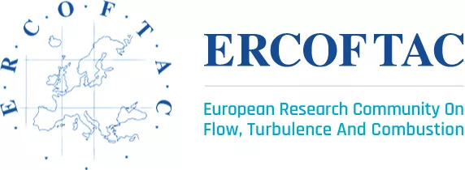 | 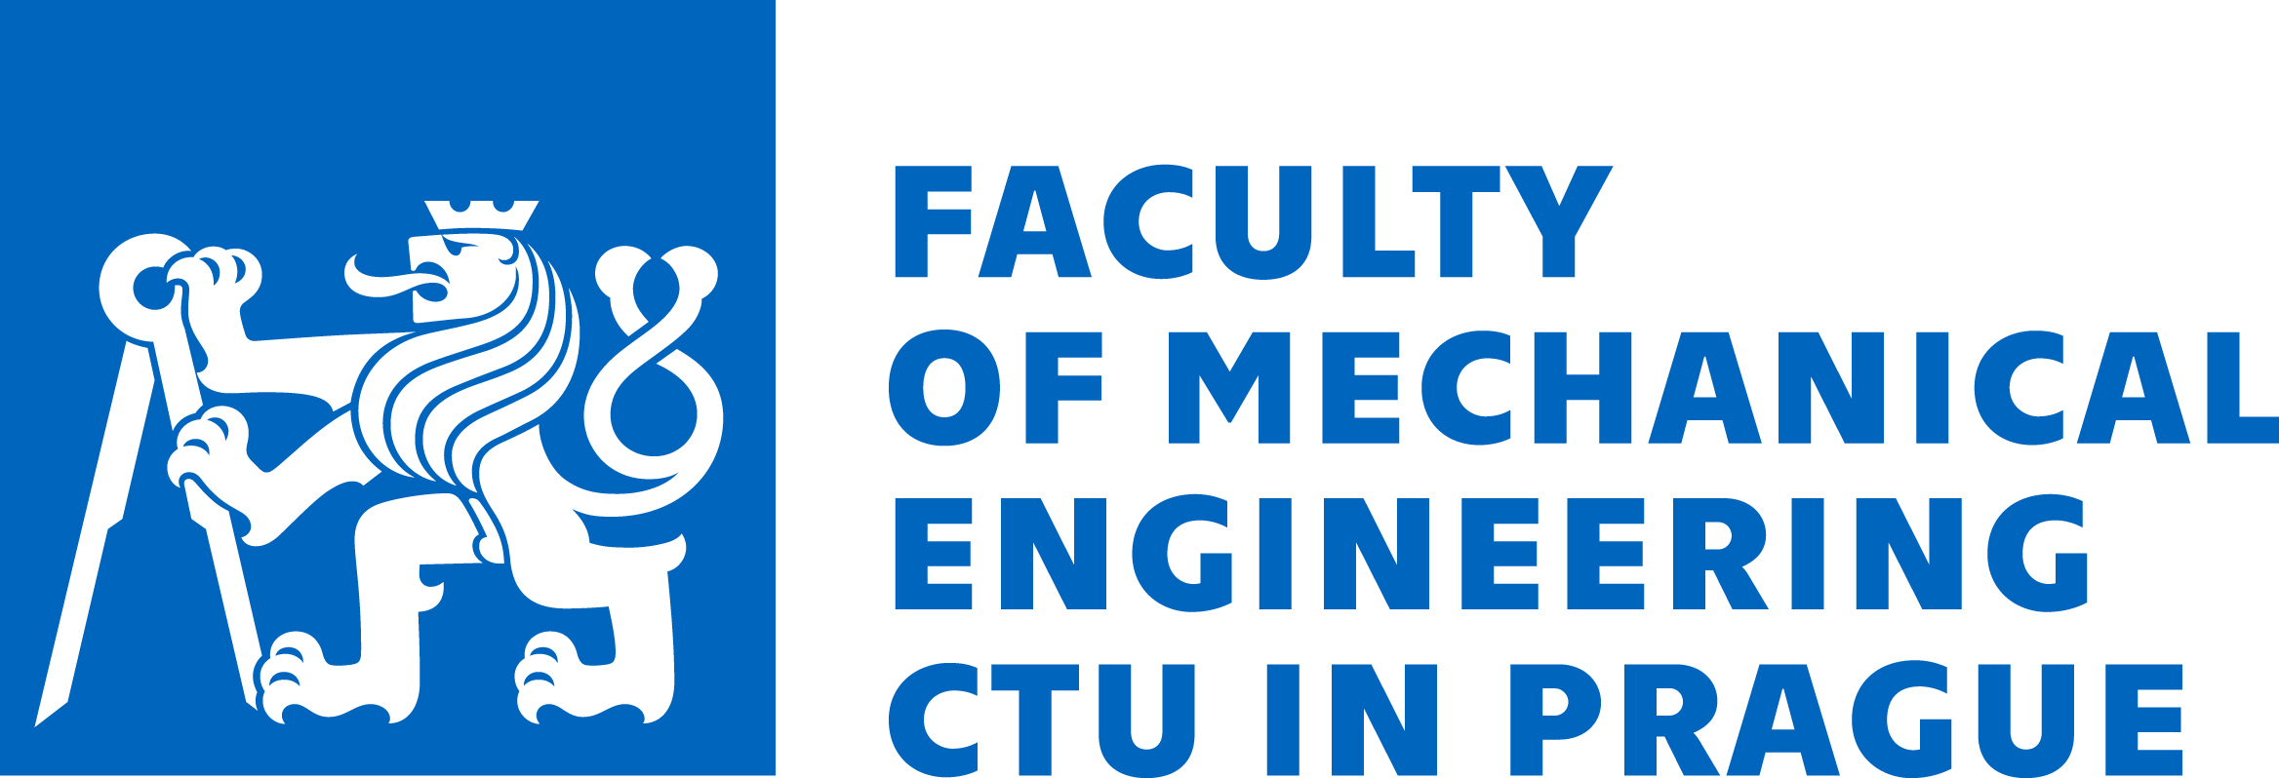

ERCOFTAC Spring Festival, April 6-7-8, 2022
Hosted by the Faculty of Mechanical Engineering, Czech Technical University in Prague

Meeting will be held in the lecture room T4:D1-366, third floor of the main building
Technická 4, Praha 6 – Dejvice, 166 07, N 50°6.19100', E 14°23.48700'

Programme

Wednesday, April 6th, 2022
The whole day is dedicated to excursion to various facilities and laboratories of the Czech PC ERCOFTAC members. Some of the facilities are in Prague, some are in other places around. All excursions will be organized in groups, depending on the interest of participants. It is suggested to choose one excursion from the list below:
- Aerodynamic laboratory in Nový Knín – offered by the Institute of Thermomechanics, CAS
- Centre of Vehicles for Sustainable Mobility in Roztoky u Prahy – offered by the Department of Automotive Engineering, FME CTU
- Turbulence laboratory in Prague – offered by the Institute of Thermomechanics, CAS
- Fluid mechanics laboratory in Prague – offered by the Department of Fluid Mechanics and Thermodynamics, FME CTU

For all excursions the participants meet on April 6th at 9:00 in front of the main building of the Faculty of Mechanical Engineering. From this place individual groups of participants will travel to their destinations. Only participants who registered for the excursion can be admitted.

Thursday, April 7th, 2022
This day is reserved for scientific programme, mainly presenting the scientific activities of the Czech PC ERCOFTAC member organizations and their partners.

8:45 – 9:00 Opening – by the Czech PC, CTU and ERCOFTAC representatives
9:00 – 10:30 Presentations by the Department of Automotive Engineering, FME CTU Prague
- Jiří Vávra, Zbyněk Syrovátka, Michal Takáts: Hydrogen internal combustion engine - experimental results
- Ivan Bortel, Jiří Vávra, Michal Takáts: Potential of dual fuel compression ignition engine to decrease global warming emissions
- Zbyněk Syrovátka, Michal Takáts, Jiří Vávra: Advanced combustion system for gas engines
- Oldřích Vítek, Vít Doleček, Zbyněk Syrovátka, Jiří Vávra, Michal Takáts: Natural gas SI internal combustion engine equipped with scavenged pre-chamber
10:30 – 11:00 Break
11:00 – 12:00 Presentations by Faculty of Mechanical Engineering, BUT Brno
- Pavel Rudolf: Cavitating flows: experiments, simulations, applications
- David Štefan: Swirling flows and spiral vortex breakdown in diffusers
- Jan Jedelský: Recent advances in spray technologies for flue gas cleaning and Carbon Capture
- František Lízal: The flow of rigid glass fibres in an airway bifurcation under steady flow conditions
12:00 – 14:00 Lunch break
14:00 – 15:00 Presentations by the Department of Technical Mathematics, FME CTU Prague
- Jan Halama, Vladimír Hric, Jiří Fürst: Numerical simulation of two-phase flow of wet steam in turbines
- Jan Valášek, Petr Sváček: Numerical simulation of human phonation
- Jiří Fürst: Mathematical modeling and numerical simulations of flows with laminar-turbulent transition
15:00 – 16:00 Presentations by Institute of Thermomechanics, Czech Academy of Sciences
- Václav Uruba: Overview of research activities in the Laboratory of Turbulent Shear Flows
- Jindřich Hála, Martin Luxa, Tomáš Radnic, David Šimurda: Experimental modelling of transonic flow in internal channels of turbomachines
- Štěpán Nosek: Recent research and applications of atmospheric dispersion modelling
- Jan Pech: Finite volumes and spectral/hp elements: applications in fluid dynamics
16:00 – 16:30 Break
16:30 – 18:00 Presentations by Faculty of Mechanical Engineering. CTU Prague
- Jan Klesa, Jiří Brabec, Tomáš Čenský, Robert Theiner, Aleš Kratochvíl, Nikola Žižkovský, Pavel Hospodář: Development of Aircraft at the Department of Aerospace Engineering
19:00 – 22:00 Social dinner

Friday, April 8th, 2022
The last day is mainly devoted to administrative meetings of ERCOFTAC bodies

9:00 – 12:00 KNC/SPC Meetings: Presentation of the new members of the Czech PC
- Institute of Mathematics, Czech Academy of Sciences
  - Jakub Šístek: Multilevel domain decomposition methods for problems of incompressible flows
  - Šárka Nečasová: Mathematical analysis of the motion of fluids and application to fluid structure interaction
  - Ondřej Kreml: What is a correct notion of solution to Euler equations?
- Institute of Theoretical and Applied Mechanics, Czech Academy of Sciences
  - Arsenii Trush: Simulation of turbulent wind and weather conditions in a climate wind tunnel and their impact on buildings and structures
12:00 – 14:00 Lunch break
14:00 – 15:30 ERCOFTAC Executive Committee meetings

